**Drug Discovery Using Neural Networks**

**Problem Statement**

Previously neural networks have become an efficient method for data analysis in the field of drug discovery because the volume of data is very large so to handle it efficiently and do the discovery of drugs deep learning is preferred. Results generated by deep Q-Learning are more accurate. The early problems encountered with neural networks such as overfitting and overtraining have been addressed resulting in a technique that surpasses traditional statistical methods. Deep Q-Learning have thus mainly survived up its promise, that is to overcome QSAR statistical problems. So, in this research a reinforcement learning technology, called Deep Q-learning, together with an RNN is to be proposed for drug discovery which will give more accurate results.

**Background**

There were many techniques used in drug discovery all aimed at shortening the time to identify development candidates. Previously the data is of Larger volumes so as the technology developed the use of machine learning techniques are preferred. Besides established methods like support vector machines (SVM), neural networks(NN) and random forest which have been utilized to develop QSAR models for a long time, methods like matrix factorization and deep learning are also used in this field to do the drug discovery. CNN are also used to discover drugs. Self-Organizing Map (SOM) or Kohonen neural network is also used.

(RF)

**Methodology**

**Step 1: Data collection and dataset preparation**

This will involve collection of data with chemical structures and activity data after this preprocessing is applied to extract features.

**Step 2: Developing a Deep Q-learning technique for Drug Discovery**.

A reinforcement learning technology, called Deep Q-learning, together with an RNN is to be developed for drug discovery.

**Step 3: Training and experimentation on datasets**

The Deep Q-learning model is then trained on the training data set to do drug discovery accurately.

**Step 4: Deployment and analysis on real life scenario**

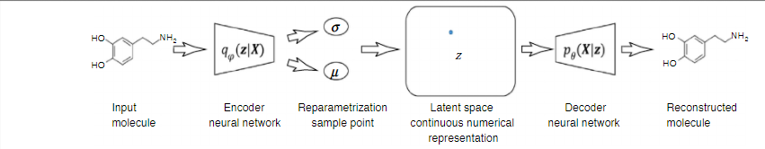

Figure.1 Work flow in discovering molecules of drugs [Chen, Hongming, et al. "The rise of deep learning in drug discovery." *Drug discovery today* (2018).]

The trained and tested discovering molecules of drugs model will be deployed in a real-life scenario for further analysis where both positive and failure cases will be leveraged for further improvement in the methodology and it will follow the above workflow.

**Experimental Design**

**Dataset**

Dataset for drug discovery using neural networks with chemical structures and activity data are available for free i.e., ChEMBL or ChEMBLdb which can be used for experimentation and evaluation. URL to download this dataset is https://www.ebi.ac.uk/chembl/

**Evaluation Measures**

Measures such as Classification error, Computational cost, Accuracy, Loss, EOR (enrichment over random) can be used for calculating the accuracy of drug discovery using neural network.

**Software and Hardware Requirements**

Python based Computer Vision and Deep Learning libraries will be exploited for the development and experimentation of the project. Tools such as Anaconda Python, and libraries such as, Tensorflow, and Keras will be utilized for this process. Training will be conducted on NVIDIA GPUs for training the Deep Q-learning technique for Drug Discovery.